Teacher notes:

This laboratory investigation has students use 3 different microscope slids—A, B, and C. The teacher needs to prepare the slides ahead of time. One of the slides, say slide A, should be clean and uncoated. Another slide, in this case slide B, should be coated with original Rainx water repellent. The third slide, slide C, needs to be coated with an antifog product. Just follow the instructions on the package. Make sure this is completed before class and do not let students know which products are on which slide.

Original Rainx can be found at many stores such as Walmart:

Rainx also makes anti-fog products for interior glass surfaces. Other products are also available:

Name: ____________________________
Investigating Wetting of Surfaces

Date: __________________
Hour: _____

Introduction
The way water interacts with the surface of an object can have important consequences. In this lab, you will learn more about different surface coatings and their uses.
Equipment
- pre-treated microscope slides
- beaker
- pipette
- hot plate

Part A: Observing Surface Coatings

Introduction

Important: When handling glass microscope slides do not touch the surface of the slides. Hold them only by their sides or the taped portion.
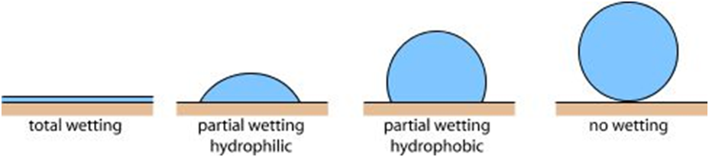
Your teacher will provide you with 3 microscope slides labeled A-C. One of these slides is plain glass, and the rest have been treated with different glass treatments to change the surface properties. In this part of the lab, you will observe how water acts differently on each of these surfaces.

superhydrophobic
superhydrophilic

Questions

- Using the above diagrams, do your best to define “hydrophilic.” You probably know what “hydro” means. Perhaps you can make a good guess about what “philic” means if you consider the word “Philadelphia.” “Delphia” means city and Philadelphia is nicknamed the “city of brotherly love.”

- What does “hydrophobic” mean? Hint: think about what a “phobia” is.

Procedure—Part A
- On each glass slide, place a drop of water using the pipette. Look at the shape the water drops take on the glass slides. In the data table below, describe or carefully sketch what they look like.
- Next, pick up each slide with a water droplet and tilt them from side to side. How does the water drop behave on each slide?
- Using your observations from 1-3 and the diagram above, determine if the surface of each glass slide is hydrophilic or hydrophilic.
- Which slide is the most hydrophilic? ___________
- Which slide is the most hydrophobic? ___________
- Gently dry the slides with a paper towel, careful not to wipe the slides very hard.
Slide | Water Drop Shape | Behavior of Drop When Tilted | Type of Surface  (hydrophilic or hydrophobic)
A
B
C

Part B: Increasing Visibility in a Rain Storm

Introduction
If you have ever driven through a heavy downpour, you know rain can make it difficult to see the road or other cars. To improve visibility during a rainstorm, it is best if the windshield is able to shed water as fast as possible. In this part of the lab, you will test the surface coatings from Part A and decide which would be the best product to apply to the outside of a windshield to improve visibility during a rainstorm.
Prediction
In Part A, you observed the effect on water of different surface coatings. Using these observations, would you expect a hydrophobic or hydrophilic surface to shed water fastest? Which glass surface—A, B, or C—do you expect to work best in a rain storm? Use 2-3 sentences. Explain your answers and use evidence from Part A to support your answers.

Procedure—Part B
- Fill a small beaker of water.
- Hold the microscope slide with coating A over a sink at an angle. When ready, use your pipet to pour several drops of water down the side of the slide. Observe the water moving on the slide and record your observations in the table, below.
- Repeat steps 1-2 for the other coated slides.
- Dry the slides gently using a paper towel.
Glass Coating | Observations
A
B
C
- Compare your observations for Part A and for Part B. Do you notice a relationship between a surface coating’s behavior in Part A and its behavior in Part B? If yes, state the relationship below.

- Was your prediction for the best rain coating correct? If not, provide 2-3 reasons the experiment may have come out differently than you had predicted.

Part C: Anti-Fogging Properties

Introduction
Another important application for glass treatments is to avoid the reduced visibility caused by the condensation forming on glasses, goggles, windshields and other glass and plastic surfaces. In this section, you will predict which glass coating avoids this loss of visibility and perform an experiment to test your prediction.
Prediction
Use your observations from Part A to predict what type of surface coating has better anti-fogging properties, hydrophobic or hydrophilic. Which glass surface—A, B, or C—do you expect to work the best? Explain your answers and use evidence from Part A and B to support your answers.

Procedure
- Fill a beaker half full with distilled water and place it on a hot plate.
- Wait until the water is hot, but not boiling (a few minutes). Unplug the hot plate when the water is steaming, but not boiling.
- Hold each slide above the beaker for 30 s. Before removing each slide, note the following observations: Has water condensed onto the slide? Has visibility been reduced through the glass? (Has it become foggy?) Record your observations in the table, below.
Glass Coating | Did Water Condense? | Has Slide Become Foggy?
A
B
C
- Compare your observations for Part A with your observations for Part C. Do you notice a correlation to the two behaviors? State your correlation below.

- Was your prediction for the best anti-fogging agent correct? If not, provide 2-3 reasons the experiment may have come out differently than you had predicted.

